**WHITE BOX & BLACK BOX TESTING PADA APLIKASI EVENTGUE**



Disusun Oleh:

Maulana Abdul Siddiq (16090112) Kelas 6A

**PRODI D4 TEKNIK INFORMATIKA**

**POLITEKNIK HARAPAN BERSAMA**

**TEGAL**

**2019**

**White Box Testing**

1. Flowchart

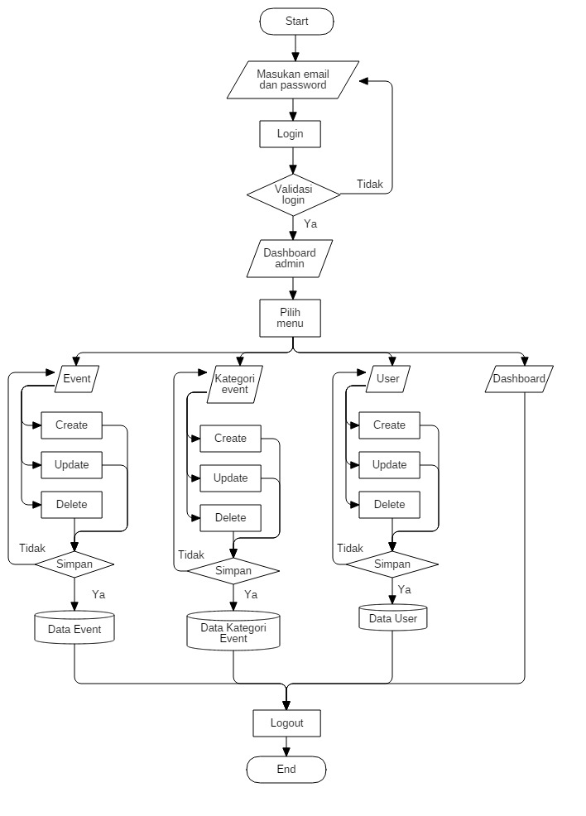

1. Control Flow Graph

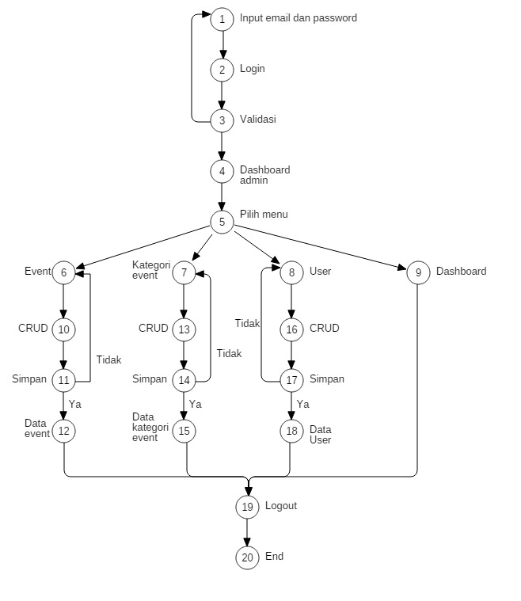

1. Cyclomatic Complexity

**(E – N) + 2**

Dari Flowchart yang dibuat terdapat 4 decision, jadi dilakukan perhitungan sebagai berikut:

**26 - 20 + 2 = 8**

1. Basic Path
2. Path 1 : 1-2-3-4-5-6-10-11-12-19-20
3. Path 2 : 1-2-3-1-2-3-4-5-6-10-11-12-19-20
4. Path 3 : 1-2-3-4-5-6-10-11-6-10-11-12-19-20
5. Path 4 : 1-2-3-4-5-7-13-14-15-19-20
6. Path 5 : 1-2-3-4-5-7-13-14-7-13-14-15-19-20
7. Path 6 : 1-2-3-4-5-8-16-17-18-19-20
8. Path 7 : 1-2-3-4-5-8-16-17-8-16-17-18-19-20
9. Path 8 : 1-2-3-4-5-9-19-20

**Black Box Testing**

Kita akan menguji sistem menggunakan Black Box Testing dengan teknik Boundary Value Analysis (BVA) dan Tabel Kebenaran.

1. Boundary Value Analysis (BVA)
   1. Date of Event

|  |  |  |
| --- | --- | --- |
| **Invalid Partition** | **Valid Partition** | **Invalid Partition** |
| 0 | 1 | 32 |
| -1 | 2 | 33 |
| -2 | 3 | 34 |
| -3 | 4 | 35 |
| -4 | ... | 36 |
| ... | 31 | ... |

* 1. Event

|  |  |  |  |  |
| --- | --- | --- | --- | --- |
| **Nama Kolom** | **Invalid** | **Valid** | **Invalid** | **Valid** |
| Id_event | 0 | 1 | 21 | 20 |
| Id_kategori | 0 Character | 1 Character | 21 Character | 20 Character |
| Judul | 0 Character | 1 Character | 21 Character | 20 Character |
| Tanggal | 0 | 8 | 9 | 8 |
| Deskripsi | 0 Character | 1 Character | 256 Character | 255 Character |
| Gambar | 0 Character | 1 Character | 256 Character | 20 Character |

1. Decision Table Testing
   1. Login

|  |  |  |  |  |
| --- | --- | --- | --- | --- |
| Email | F | T | F | T |
| Password | F | F | T | T |
| Action | Error: Please enter Email | Error: Please enter Password | Error: Please enter Email | Login Succes |

User akan berhasil login apabila email dan password yang dimasukkan benar (true)

* 1. Event

|  |  |  |  |  |  |  |  |  |  |  |  |  |  |  |  |  |
| --- | --- | --- | --- | --- | --- | --- | --- | --- | --- | --- | --- | --- | --- | --- | --- | --- |
| Judul | T | T | T | T | F | F | F | F | T | T | T | T | F | F | F | F |
| Tanggal | T | T | T | F | F | F | T | T | T | F | F | F | T | T | T | F |
| Deskripsi | T | T | F | F | T | T | F | F | T | T | F | F | T | T | F | F |
| Gambar | T | F | T | F | T | F | T | F | T | F | T | F | T | F | T | F |
| Action | Success | No | No | No | No | No | No | No | No | No | No | No | No | No | No | No |

Form tambah event akan berhasil ditambahkan jika kolom judul, tanggal, deskripsi dan gambar bernilai benar (true) selain itu gagal.